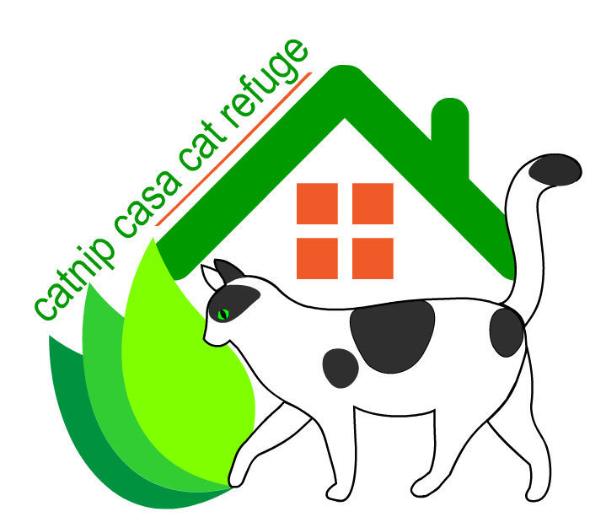
Contact Penny Leisch  Telephone 602-738-5568  Cell 602-738-5568  Email penny@catnipcasa.org  Website http://www.catnipcasa.org | FOR IMMEDIATE RELEASE  April 11, 2016

Love & Cuddles Respite Care for Dogs & Cats

A place for pets to stay while their people get well.
Austin, TX, April 11, 2016– Love & Cuddles Respite Care for dogs and cats saves tax dollars and pets’ lives. Catnip Casa Cat Refuge proudly announces receipt of a $2,500 first steps grant from The Binky Foundation in New York.
Love & Cuddles Respite Care keeps pets from being relinquished to shelters when the owner needs medical care. These animals have homes and loving owners. Still, many people with limited income (disabled, seniors, veterans, etc.) have no money for boarding and are without friends or family to care for pets during hospitalization. The pets often end up in a shelter—a poor outcome for the animal and the person. Love & Cuddles Respite care also improves the outcome of the owner’s medical care when the owner isn’t grieving and despondent over the loss of their pet while they are ill and need to focus on their own wellbeing.
“We have worked hard to make Love & Cuddles Respite Care a program that will benefit senior and disabled members of the community, as well as benefitting the animal shelters by eliminating the burden of taking in pets that already have homes and loving owners. The Binky Foundation grant will improve the intake foster home facilities,” said Penny Leisch, President of Catnip Casa Cat Refuge. “What we need most is many more respite care foster homes. This is an ideal volunteer opportunity for active seniors or busy adults and families who love pets and don’t want a long-term or full time commitment.”
People who have no resources for pet care when they need hospitalization or extended medical treatment often avoid or delay care to protect their pets, at great risk to their health. Numerous programs for hospital visitation and pet therapy repeatedly prove the value of pets in our lives. Love & Cuddles Respite Care is a young program with a plan to grow into a valuable community service. We want this type of care to become a standard community resource to keep pets and people together. Our immediate focus is on growing our foster network, along with building community support and a stable donation base. We need a lot more respite care foster homes. Our goal is to expand the program and develop a model for other organizations to use too. Catnip Casa Cat Refuge rates Gold on GuideStar, a demonstration of our commitment to the community, our volunteers, and our donors, to grow responsibly.
---------------
Catnip Casa Cat Refuge provides care for cats that require extensive rehab or lifelong pawspice care due to age, disease, or disabilities that do not allow them to remain in their home or community due to medical needs or behavioral challenges. We also provide respite foster care for pets to keep them out of shelters and preserve the animal-human relationship when seniors, disabled persons, and other people with limited income need hospitalization. Last, but not least, we support TNR as a humane means of managing community cats and a vital component of long-term solutions to managing feral populations.
# # #
If you would like more information about this topic or wish to become a respite care foster home for dogs or cats, please contact Penny Leisch at 602-738-5568 or email at penny@catnipcasa.org.

